

CCP REPORT

TITLE: LIVE CURRENCY CONVERTER SYSTEM
Course: Programming Fundamentals (PF)
Semester: 1st
Submitted by: Mohsin Ali Mughal
Roll Number: 74669
Submitted to: SIR ILYAS
Date: 01/12/2026

1. ABSTRACT
This project involves the development of a Live Currency Converter using the C programming language. Unlike standard first-semester projects that use hardcoded (static) values, this system connects to the internet to fetch real-time exchange rates. The program utilizes the system() command to execute web requests via curl, stores the data in a local text file, and utilizes advanced file handling and string parsing techniques to extract specific currency rates. This project demonstrates proficiency in loops, conditional statements, file I/O operations, and string manipulation.

2. INTRODUCTION
In the modern global economy, exchange rates fluctuate every second. A currency converter that uses fixed rates (e.g., 1 USD = 280 PKR) becomes obsolete immediately. The objective of this project was to build a console-based application that offers real-time accuracy.
The project is built in C, a language known for its system-level access. While C does not have built-in web capabilities, this project overcomes that limitation by integrating with the operating system's command line to fetch live JSON data from an external API (exchangerate-api.com).

3. PROBLEM STATEMENT
Most introductory programming projects suffer from the "Static Data Problem."
- Static Rates: Hardcoding rates means the program is incorrect as soon as the market moves.
- No Persistence: Most simple programs lose data when closed.
- Complexity: Connecting C to the internet usually requires complex libraries (libcurl) that are beyond the scope of a 1st-semester syllabus.
Solution: This project solves these problems by using a "File-Based Data Bridge." The program downloads live data to a text file (rates.txt) and reads from it, keeping the C code simple while achieving advanced functionality.

4. FEATURES
- Live Data Fetching: Downloads the latest exchange rates relative to USD.
- File Persistence: Caches data in a local file (rates.txt), allowing the program to work even if the internet briefly disconnects after the first fetch.
- Menu-Driven Interface: A clean do-while loop interface with error handling.
- Custom Currency Search: Users can input any 3-letter currency code (e.g., JPY, CAD, AUD) to find rates dynamically.
- Error Handling: Detects if the data file is missing or if an invalid currency code is entered.

5. TECHNICAL IMPLEMENTATION
The project is implemented using the following core programming concepts:

A. Libraries Used
- <stdio.h>: For Input/Output operations and File handling.
- <stdlib.h>: For the system() function and memory management.
- <string.h>: For strstr (search) and strlen (length) functions.

B. Key Algorithms
- Fetching Data (System Call): We use the command system("curl -s URL > rates.txt"). This instructs the underlying Linux/Windows command line to download the JSON data and save it to a text file.
- Parsing Data (String Search): Since the data is in JSON format (e.g., "PKR":278.50), we cannot simply read it as a list. We use:
  - strstr(buffer, "CODE"): To find the location of the currency code.
  - strtof(pointer, NULL): To convert the text string immediately following the code into a float number.
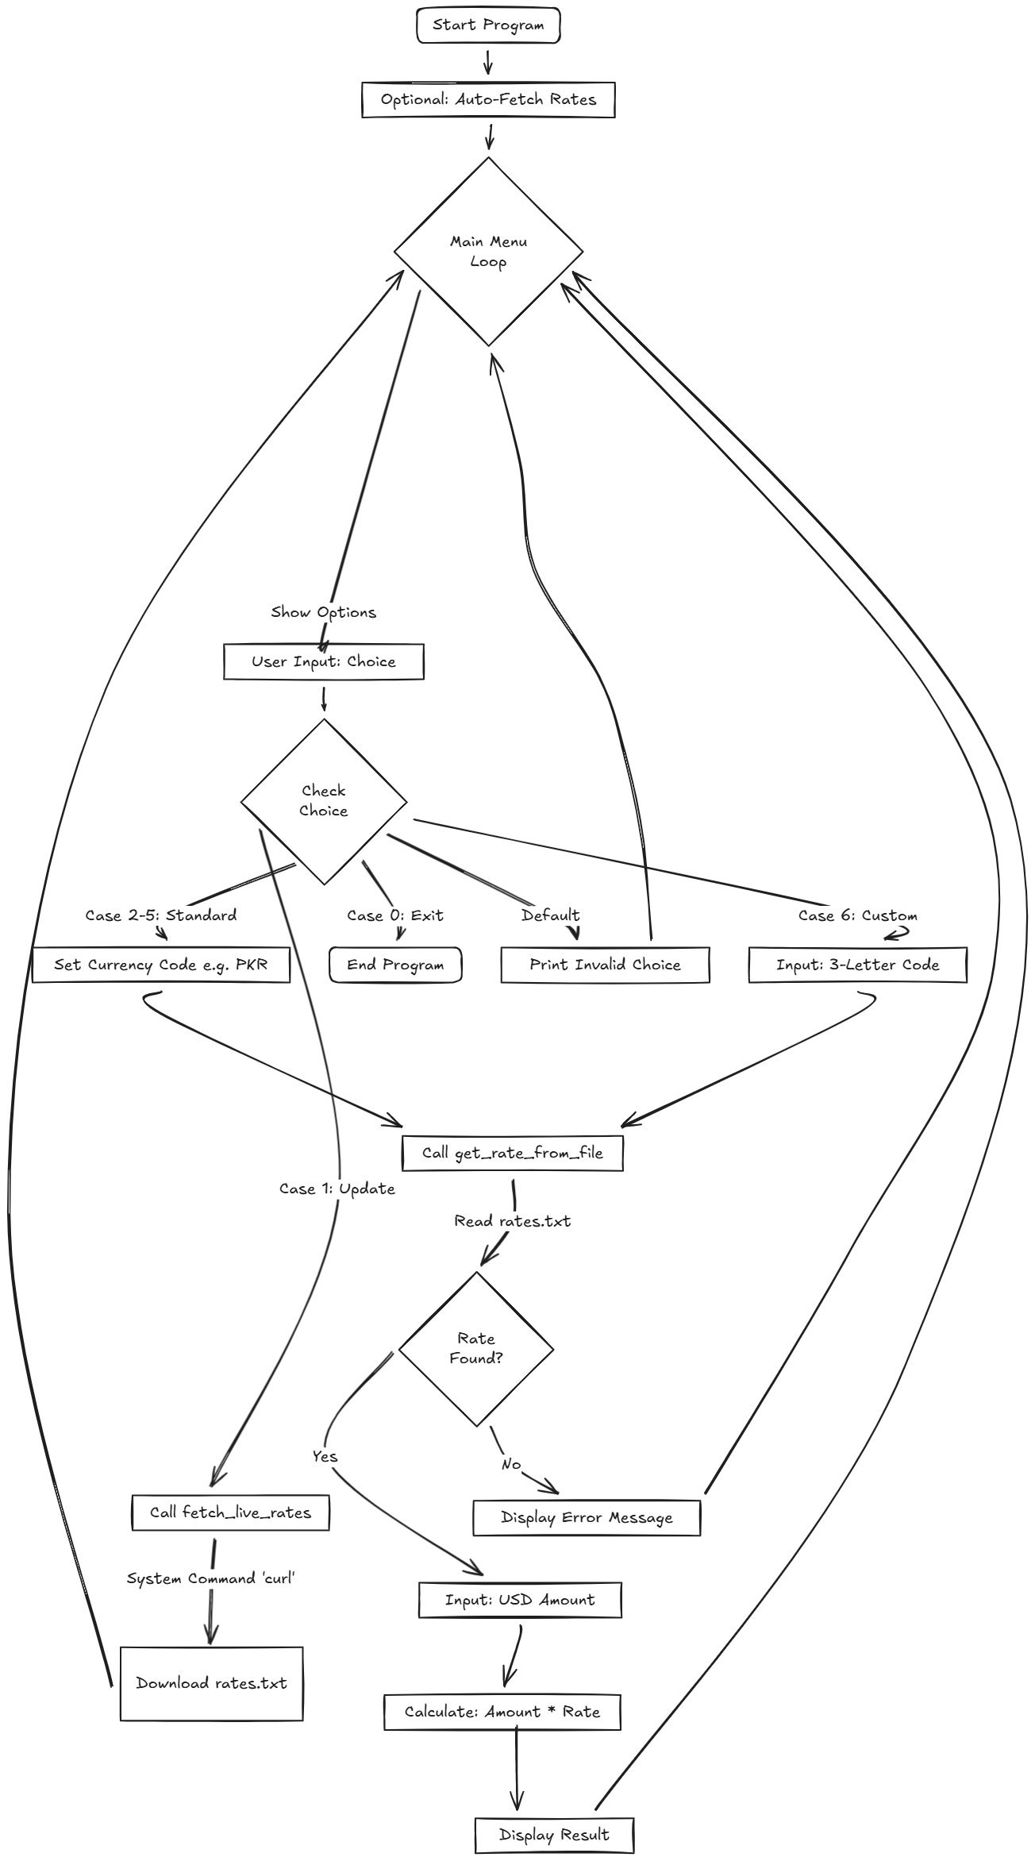
- The Main Loop: A do-while loop controls the flow, ensuring the user can perform multiple conversions without restarting the program. The screen is cleared using system("clear") for a professional user experience.
6. FLOWCHART

7. EXPERIMENTAL OUTPUTS (SCREENSHOTS)
This section demonstrates the working functionality of the system under various test cases to validate the algorithms for fetching data and calculating conversions.

Test Case 1: Application Start & Main Menu
Description: The program launches and displays the clear screen interface with all available options.
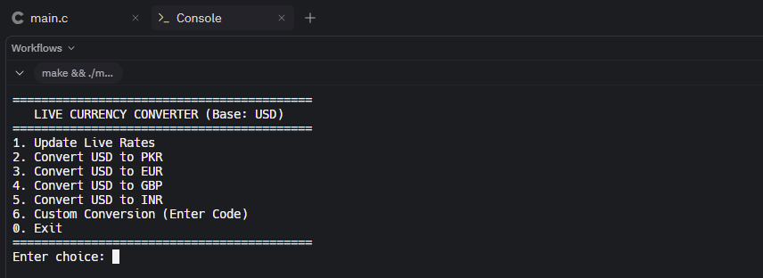 (Figure 10.1: Main Interface)

Test Case 2: Live Data Update (System Call)
Description: The user selects Option 1. The program executes the curl command, successfully connects to the API, updates the rates.txt file, and confirms success.
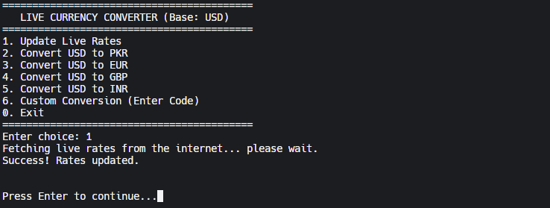 (Figure 10.2: Successful API Data Fetch)

Test Case 3: Standard Conversion (USD to PKR)
Description: The user selects Option 2 and inputs "100" USD. The program reads the PKR rate from the file and calculates the correct result.
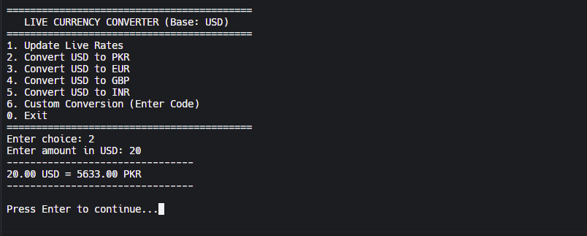 (Figure 10.3: Calculation Logic Verification)

Test Case 4: Custom Currency Search (Search Algorithm)
Description: The user selects Option 6 and manually types "JPY" (Japanese Yen). The search algorithm successfully finds the JSON key in the text file and performs the conversion.
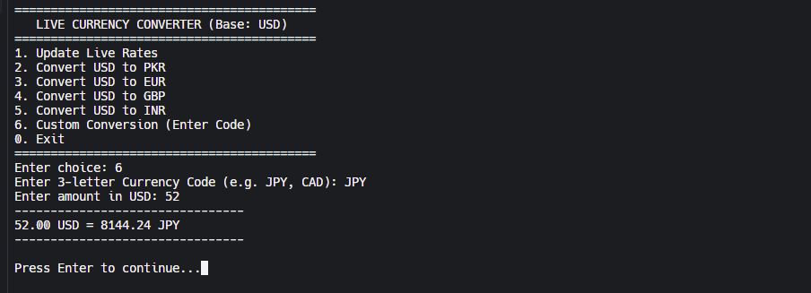 (Figure 10.4: Dynamic String Search Output)

Test Case 5: Error Handling & Validation
Description: The user enters a currency code that does not exist (e.g., "XYZ"). The system detects the failure and prompts a specific error message instead of crashing.
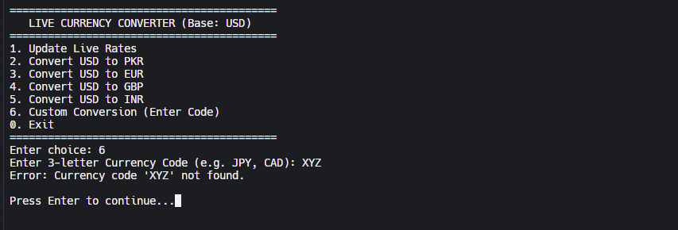 (Figure 10.5: Validation Logic)

8. LIMITATIONS & FUTURE IMPROVEMENTS
Limitations:
- The program relies on an external API provider. If the website goes down, the live update feature stops working.
- It requires an active internet connection for the "Update" feature.
Future Improvements:
- Historical Data: Save past rates to a CSV file to show trends (Graphing).
- Offline Mode: If the internet is down, use the last known rates saved in the file automatically.
- GUI: Upgrade from a console interface to a graphical window using C# or Python in future semesters.

9. PSEUDO CODE: LIVE CURRENCY CONVERTER
START PROGRAM
- DEFINE constant URL as "api source"
- DEFINE constant FILE_NAME as "rates.txt"
- DECLARE variables: choice, amount, rate, currency_code
- FUNCTION Fetch_Rates: a. EXECUTE system command "curl" to download URL data into FILE_NAME b. PRINT "Rates Updated"
- FUNCTION Get_Rate (input: target_code): a. OPEN FILE_NAME in Read Mode b. READ file content into buffer c. SEARCH buffer for target_code d. IF found: i. EXTRACT number value after the code ii. RETURN rate value e. ELSE: i. RETURN -1 (Error)
- MAIN LOOP (Repeat until User selects Exit): a. CLEAR Screen b. DISPLAY Menu Options: - 1. Update Rates - 2. Convert to PKR - 3. Convert to EUR - 4. Custom Conversion - 0. Exit c. READ user input into choice
d. SWITCH (choice): - CASE 1: - CALL Fetch_Rates()
- **CASE 2, 3, 4 (Standard Conversions):**
- SET `target_code` (e.g., "PKR", "EUR")
- CALL `Get_Rate(target_code)` and store in `rate`
- **IF** `rate` is valid:
- **PROMPT** "Enter USD Amount"
- **READ** `amount`
- **CALCULATE** `result = amount * rate`
- **PRINT** `result`
- **ELSE**:
- **PRINT** "Error: Rate not found"

- **CASE 6 (Custom):**
- **PROMPT** "Enter 3-letter Code"
- **READ** `currency_code`
- CALL `Get_Rate(currency_code)`
- (Proceed with calculation logic above)

- **CASE 0:**
- **BREAK** Loop (Exit)

- **DEFAULT:**
- **PRINT** "Invalid Choice"
e. PAUSE (Wait for user to press enter)
- END LOOP
END PROGRAM

